Name:Bainh alaa elden abdelfattah aboraya

Lab2 advanced admin1 (with special permission)

17. Attempt to run the command gnuplot. You should find that it is not

installed.

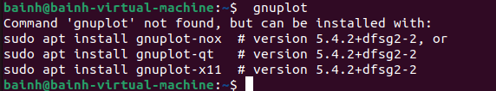

18. Search for the plotting packages.

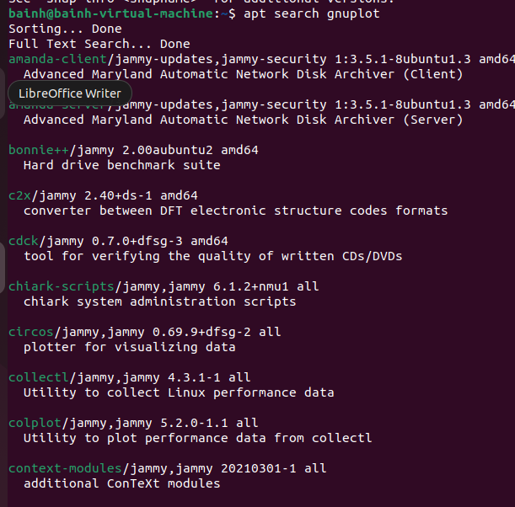

19. Find out more information about the gunuplot package.

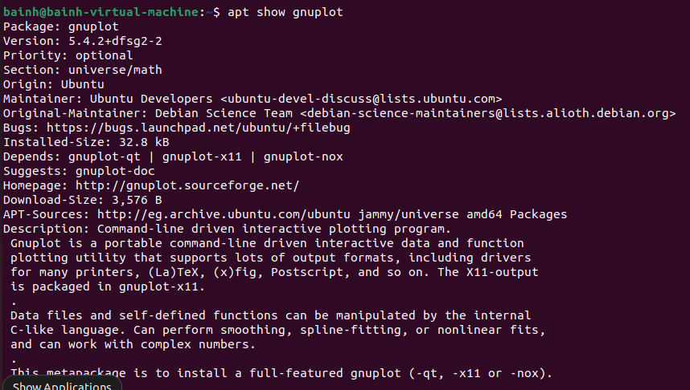

20. Install the gnuplot package.

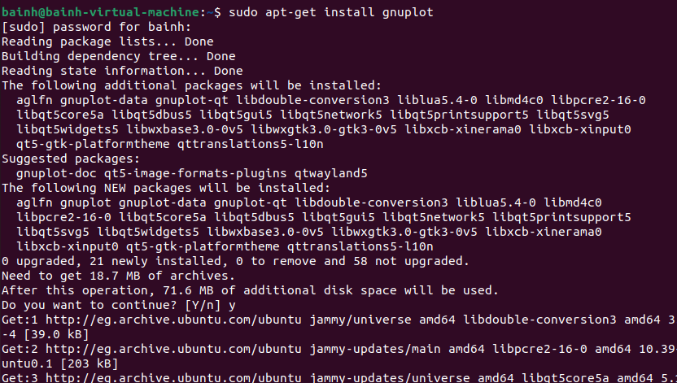

21. Attempt to remove the gunplot-common package but say no

How many packages would be removed

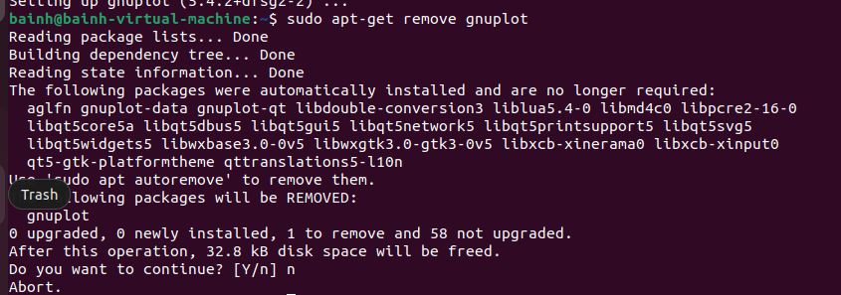

Using rpm

22. List all installed packages in your system.

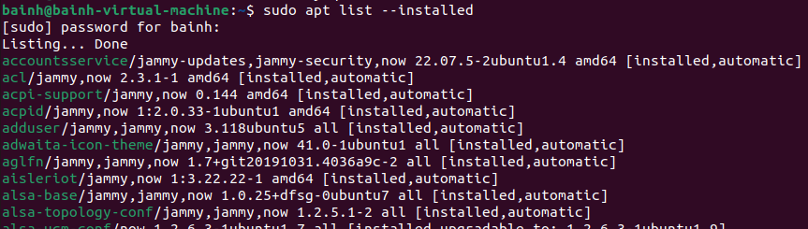

23. View the files in the initscripts package

24. Get general information about bash rpm.

25. Have the files from the pam package changed since it was

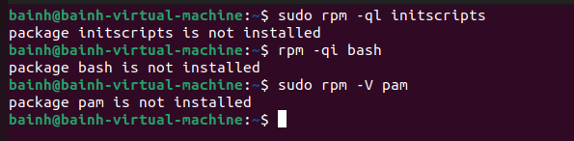

26. Which installed packages have gnome in their names?

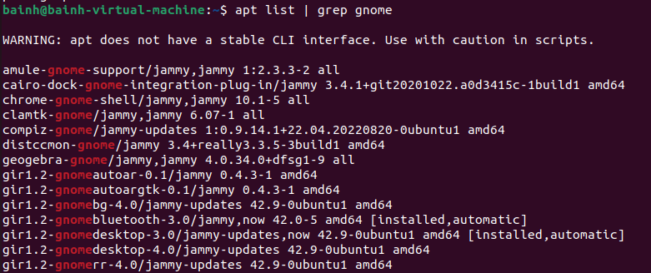

27. Install any uninstalled package from RH Enterprise Linux cds

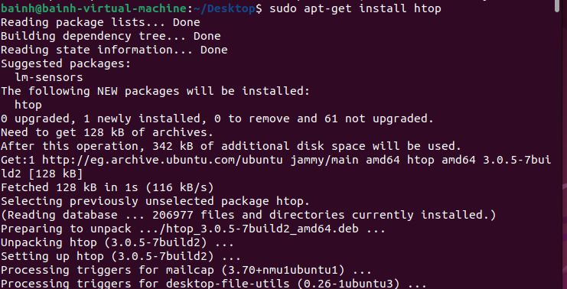

28. Search for software resemble the Photoshop software other than

Gimp and install it.

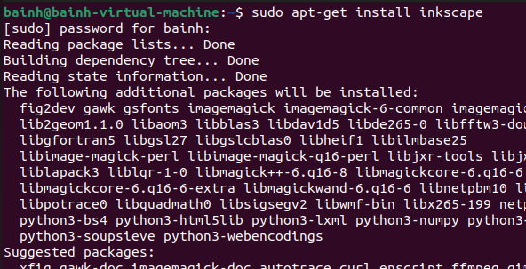

29. Create the file /etc/yum.repos.d/cdrom.repo to enable install from

the iso from the iso of Red Hat.

sudo nano /etc/yum.repos.d/cdrom.repo

[cdrom]

name=Red Hat CD-ROM Repository

baseurl=file:///media/cdrom

enabled=1

gpgcheck=0

30. Try to install any package from the new repository

sudo yum clean all

sudo yum update

sudo yum install htop

Special permissions lab

1. Using the useradd command, add accounts for the following users in your system: user1, user2, user3, user4, user5, user6 and user7. Remember to give each user a password.

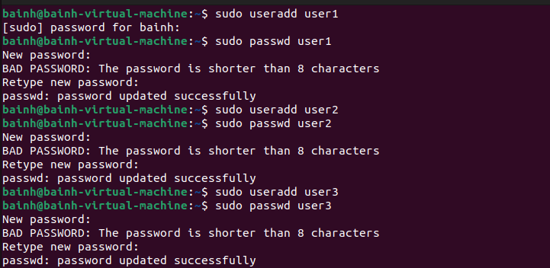

1. Using the groupadd command, add the following groups to your system.

Group GID

sales 10000

hr 10001

web 10002

Why should you set GID in this manner instead of allowing the system to set the GID by default?



setting GIDs explicitly provides better control, consistency, and organization in managing groups, especially in complex and interconnected computing environments. It ensures that the assignment of group identifiers aligns with the administrator's requirements and facilitates effective user and group management

1. Using the usermod command to add user1 and user2 to the sales secondary group, user3 and user4 to the hr secondary group. User5 and user6 to web secondary group. And add user7 to all secondary groups

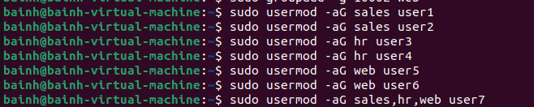

And I use –a to make sure when I add user in the secondary group don’t remove from other groups

4-Login as each user and use id command to verify that they are in the appropriate groups. How else might you verify this information?

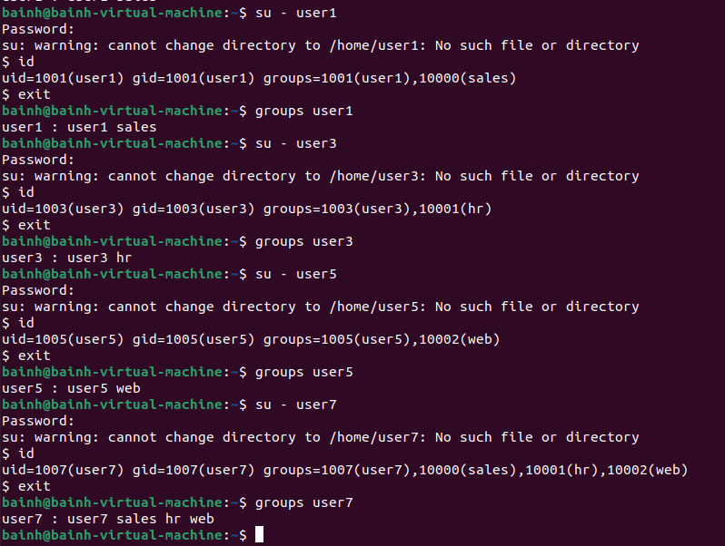

5-Create a directory called /depts with a sales, hr, and web directory within the /depts directory



6-Using the chgrp command, set the group ownership of each directory to the group with the matching name



1. Set the permissions on the /depts directory to 755, and each subdirectory to 770



8-Set the set-gid bit on each departmental directory



9-Use the su command to switch to the user2 account and attempt the following commands:

touch /depts/sales/user2.txt  
touch /depts/hr/ user2.txt

touch /depts/web/ user2.txt

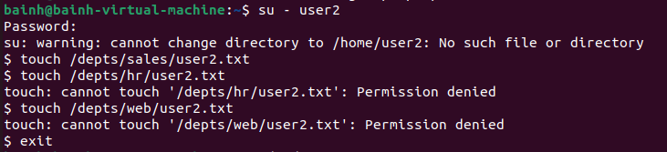



10-Configure sudoers file to allow user3 and user4 to use /bin/mount and /bin/umount commands, while allowing user5 only to use fdisk command.

Sudo visudo (command)

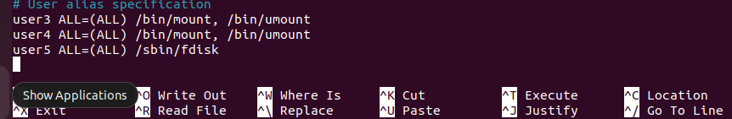

11-Login by user3 and try to unmount /boot.

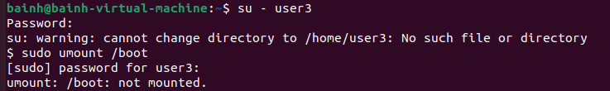

12-Login by user4 and remount /boot. Also try to view the partition table using fdisk

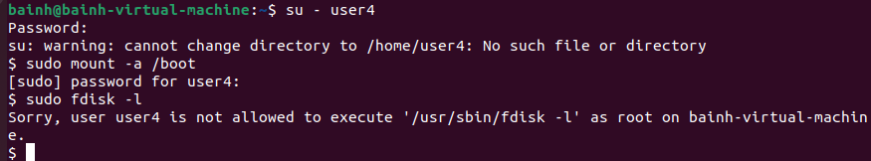

13-Create a directory with permissions rwxrwx---, grant a second group (sales) r-x permissions

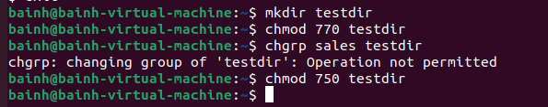

14- create a file on that directory and grant read and write to a second group (sales)

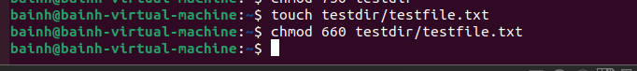

15-set the the owning group as the owning group of any newly created file in that directory.



16-Grand your colleagues a collective directory called /opt/research, where they can store generated research results. Only members of group profs and grads should be able to create new files in the directory, and new file should have the following properties:

* the directory should be owned by root
* new files should be group owned by group grads
* group profs should automatically have read/write access to new files
* group interns should automatically have read only access to new files

other users should not be able to access the directory and its contents at all

sudo mkdir /opt/research

